

Spring 2020

**Report on Project,**

**Event Management System**

**Course Code:** CSE411 | **Section:** 01

**Course title:** Software Engineering & Information System

**Submitted By,**

Abdullah Muhammad Tahir (ID: 2017-1-60-082)

Md. Raqibul Hasan (ID: 2017-1-60-090)

Tanvir Ahmed (ID: 2017-1-60-131)

**Submitted to,**

Md. Mohsin Uddin

Lecturer

Department of Computer Science & Engineering

**East West University**

Aftabnagar, Dhaka

Submission Date: 9th May 2020

**Acknowledgements**

All praise to almighty Allah Subhanu T’ala and all credit goes to him for his blessing to complete this project, Developing a web-application for “Event Management System”, as a fulfillment of one of the requirements for the course CSE411 (Software Engineering & Information System). This project has been done with optimum contribution from each of our three group members, Abdullah Muhammad Tahir, Md. Raqibul Hasan and Tanvir Ahmed, students from spring-2017, Computer Science and Engineering Department, East West University, Aftabnagar Dhaka.

Endless thanks to our project supervisor, Md. Mohsin Uddin, Lecturer, Department of Computer Science & Engineering, East West University, for his proper guidelines and valuable instructions. This project could not be brought to light without his contribution and advices.

This enormous thanks to teaching assistant (TA) of the Course CSE411, Hemayet Nirjhoy and Afsana Hossain for their academic support and directions. Their helps and supports paved the way for us to understand most of the things related to the project and complete the project in spite of having only a little prior knowledge about it at the beginning of the course.

Finally, we wish to be grateful to our teachers and friends from East West University for their appropriate and precious suggestions, moral support and valuable co-operation.

**Table of contents**

|  |  |  |
| --- | --- | --- |
| Serial No. | Topic | Page |
| 1 | Abstract of the project | 4 |
| 2 | Introduction | 4 |
| 3 | Block Diagram of the web application | 5 |
| 4 | A short introduction to the features | 6 |
| 5 | Fulfillment of **Non-Functional** Requirements: **Product Requirements** | 7 |
| 6 | Fulfillment of **Non-Functional** Requirements: **Organizational Requirements** | 8 |
| 7 | Fulfillment of **Non-Functional** Requirements: **External Requirements** | 9 |
| 8 | Fulfillment of **Functional** Requirements:  **For Admins** | 9 |
| 9 | Fulfillment of **Functional** Requirements:  **For Users** | 10-11 |
| 10 | **Other Diagrams:** Use Case Diagram | 12 |
| 11 | **Other Diagrams:** Class Diagram | 13 |
| 12 | **Other Diagrams:** Activity Diagram | 14-15 |
| 13 | **Other Diagrams:** Entity Relationship Diagram | 16 |
| 14 | **Other Diagrams:** Sequence Diagram | 17 |
| 15 | **Limitations** | 18 |
| 16 | **Conclusion** | 18 |
| 17 | **Screenshots** | 19-27 |

**Abstract of the project**

In our university, still the management system of any events or event organizing clubs are being handled in an ancient way, which is, papers and pen. Yes, in some points, google form is being used for registration facilities and Microsoft word, excel, power-point are being used for writing letters, handling data, presenting. Also, social media, mobile SMS are being used for advertising or informing about many events and important dates. The problem that arises here that we are not being able to do all these works together in just one application. So, there is no particular place to do these works orderly and arranged properly as huge number documents gets scattered here and there in storage device, sometimes many information are lost. Also, Participants or the Members who registered for a club can hardly reach the event coordinators and organizers with their questions, queries, helps and ideas. Even when organizers need to change any information about any event for unavoidable reasons, they struggle so much as they have to repeat the process of advertising and informing using social media, emails and Mobile SMS and so on. So, we felt thirst for a web application that can solve all these problems.

The main goal of developing the web application was to ease the management of an event organized by a club. So, the web application must be handy for any users considering the fact that there will be different interfaces for administrators and users at the same time. The web-application must be very user friendly for many registration purposes and we have tried our best to make it one. Because, the other challenge of developing this web-based application is to reduce the use of Microsoft applications, social networking or Google forms.

**Introduction**

We have developed a responsive web application that can solve the above-mentioned problems and make all the things easier about organizing an event for a club and also for the participants who take part in these events. In this application we will provide the liberty of updating, editing and managing any kind of information, to the people who organize events (such as administrators). People who participate in these events, will be able to know anything about these events. So, in one sentence, all the things about an event can be found in only one place, scattered information will be aligned, event management will be much easier.

**Block Diagram of the web application:**

**Home Page**

[Logo, hyper-links for navigations, sliders, list events with hyper-links]

**User Home Page**

[Social Communications such as Posting and Commenting, Request for recruitment, event registrations]

**Page for Events**

[Schedule of various events, title and description for latest held event and also upcoming events]

**Registration Page & login page**

[Registration as a user, logging in as user]

**About Club & Organizers**

Credits

**Hidden admin page**

**(Type different URL to access)**

[The web application controlling page, includes login for administrators, navigations]

**Pages for editing user and user event registrations**

[Promoting or demoting users as per recruitment request, banning users, updating payments of users as per event registration]

**Managing Events & About**

[Uploading, updating, deleting or upgrading existing event, editing about]

**A short introduction to the features**

* The web pages are responsive to any device.
* Main page includes sliders (sort of advertisements of the club, events and activities), Successful events (past events having photos and descriptions) and Upcoming event links. Also includes navigation for sign up, sign in, recruitment etc. Footer includes Facebook ID links of developers.
* Visitors can take a look at the past events and upcoming events from main page.
* Visitors can sign up as users and sign in
* User can share anything by posts and comments
* User can delete own post at any moment and report other’s posts
* User can explore events and register for different events at the same time
* User can send register for recruitment and send request for recruitment to Admin.
* Admin can update past events
* Admin can update upcoming events and also delete them if events are dropped.
* Admin can upload or delete sliders
* Admin can upload or delete about
* Admin can see user’s data (excluding passwords and other sensitive data)
* Admin can edit user’s designation as per requests by the users.
* Admin can confirm payments of participators in events.

**Fulfillment of Non-Functional Requirements:**

* **Product Requirements**

Admin URL only known by the Administrators, no one else knows.

**For Admin:** This is for highest security purpose. Only Administrators will know a special URL that is given to them by the developers. For this web application, the URL is localhost/event_management/adminlogin and this is the first step of security. Because Administrators will have to login using their unique username and password even after typing the URL. Admin Page does not have and registration facility. It has only login page. In order to register as an Admin, client has to contact developer for integrating their information. Also, the passwords are hashed so that even developers cannot access their (admin’s) account. Moreover, after logging in, if an Admin comes back to main page clicking on the organization logo at top left corner, his session will be lost. Even, he has to login with his user account and then log out of it, to access his admin account login facility again. This has been done for the highest possible security. An admin is the maintainer of the whole page. Anything he does using his account, he must do them with caution. Lastly, an admin cannot post or comment using his admin account. He has to open a user account in order to do that.

**For User:** Visitors of the web page will be able to see the latest events and upcoming events. However, to register for an event they will have to sign up (if they do not have accounts) or sign in (if they have accounts). For users the security is minimized for creating user friendly environment. If a user accidently comes back to main page, the session will not be lost like admins. He will be able to access his account again by going back or forward. The session will not be broken until he presses log out button. Anyways, if a user logs out, every link in his dashboard will route back to login page.

* **Organizational Requirements**

Any problem that an organizing club faces, will be solved. A club faces many problems while organizing an event. These problems are stated as data redundancy, repetition of information, losing information, no proper way of contacting participants etc. These problems will be solved by this web-application.

* In this web application visitors can sign up as users filling up a form. The form contains field for Name, Email, and Password & Confirm Password. Records of every user is being saved when they sign up and Admins can see them in their ‘Edit User Data’ feature. Admins can contact with users using their email ids.
* When a user registers for an event, his registration data is also saved in another table. This table can be seen by admins in their ‘Event Records’ page. Although all the registrations are saved in one table in mysql, these records are divided by links echoing the titles of the events as different events can have different participators or same participator. If same participator registers for many events he has to make payment for every event he registers for. So, this is how the records are categorized. Admins can send steps for making payment and contact with users using their contact number which was given by the users while registering for events.
* When users register for an event, he only has to type “Name of University”, “Contact Number”, and “Category, in which he is participating”. A user does not need to type in his name, email while registering for an event because these information have already been saved when they signed up as users. Also in recruitment section, users do not have to type in their name and email. Only “contact number” and “specialty”. So, these unique features saves the Admins from repetition of user’s data.
* Data of events, users cannot be lost until Admins delete them using their account. So, there is cautions, and notes everywhere in the pages where it includes editing things.
* **External Requirement**

Any upgrade such as Q/A Live, live chats between users etc. in future can be added easily. Both in admin and user dashboard the links are very well arranged. It will be very easy for any developer to add more options or features in future as per demand.

**Fulfillment of Functional Requirements:**

**For Administrators:**

* Only an Administrator will be able to add, edit or delete anything in the application such as users, members, notices, events, about and executive members.
* If we consider the web-application as a province then administrators are like King of the province. Sometime many information are needed to be edited, added, or deleted. For example, cancelling membership, banning users, upgrading membership, uploading events, uploading notices, uploading photos, changing schedule of any events (updating events), cancelling events etc. Editing page also includes the club photo and descriptions and adding or deleting executive members in ‘about’ page. These are mandatory functions for an administrators. All of these features are introduced in the web-application and it fulfills the Functional Requirements for administrators.
* Only Admin have the ability to use the contact numbers of users for sending SMS.
* Contact number is a sensitive information. It cannot be shown in recruitment section of the main page. Users can contact users with email id. However Admins can contact everyone with both email id and contact number. Because, users and members will be needed to be notified frequently about things that are uploaded, or changed by the administrators. Only administrators have the ability to see data like this.
* Admin can delete ‘reported posts’ from users
* Users can report other post but not his/her own post. This reports reach to admin and admin can take the decision to delete the reported posts.
* Admins need text editors
* In order to update events, sliders etc, user’s Admins have to have something for writing. So text editors are mandatory in the admin panel and this functional requirement has been fulfilled

**For Users:**

* Participants and members will be able to search for all events that are being organized. Signed up users will be able to Post about events and can comment in posts.
* By users, it is also meant the participants of the events and members of club. They have the ability to post about any event and comment in there. Other participants will have the liberty to see all the posts, read comments, read frequently asked questions, see schedules of the events, ask questions.
* A User will be able to delete own post and report other’s posts
* Sometimes own post needs to be deleted because asked question can already be asked or shared item can already be shared by others. So a user can delete his/her own post at any time s/he wants.
* Visitors will be able to see particular event and can register for them by signing up as users.
* Participation is open for all. But one has to sign up as user first. In the Event registration panel, there are links for various forms of various events. By considering the schedule given for the events, a participant will be able to decide to register for more than one event.
* A user will be able to register for membership.
* Anyone will be able to see the club activities in “home page” and also in the “about page”. For registering visitors have to sign up as users. Also, by considering all the rules in recruitment panel if anyone wants to join as a member of a club, then s/he can register for membership. But s/he has to wait until the season of recruitment because acceptance of request is bestowed upon Administrators.

**Other Diagrams**

**Use Case Diagram**

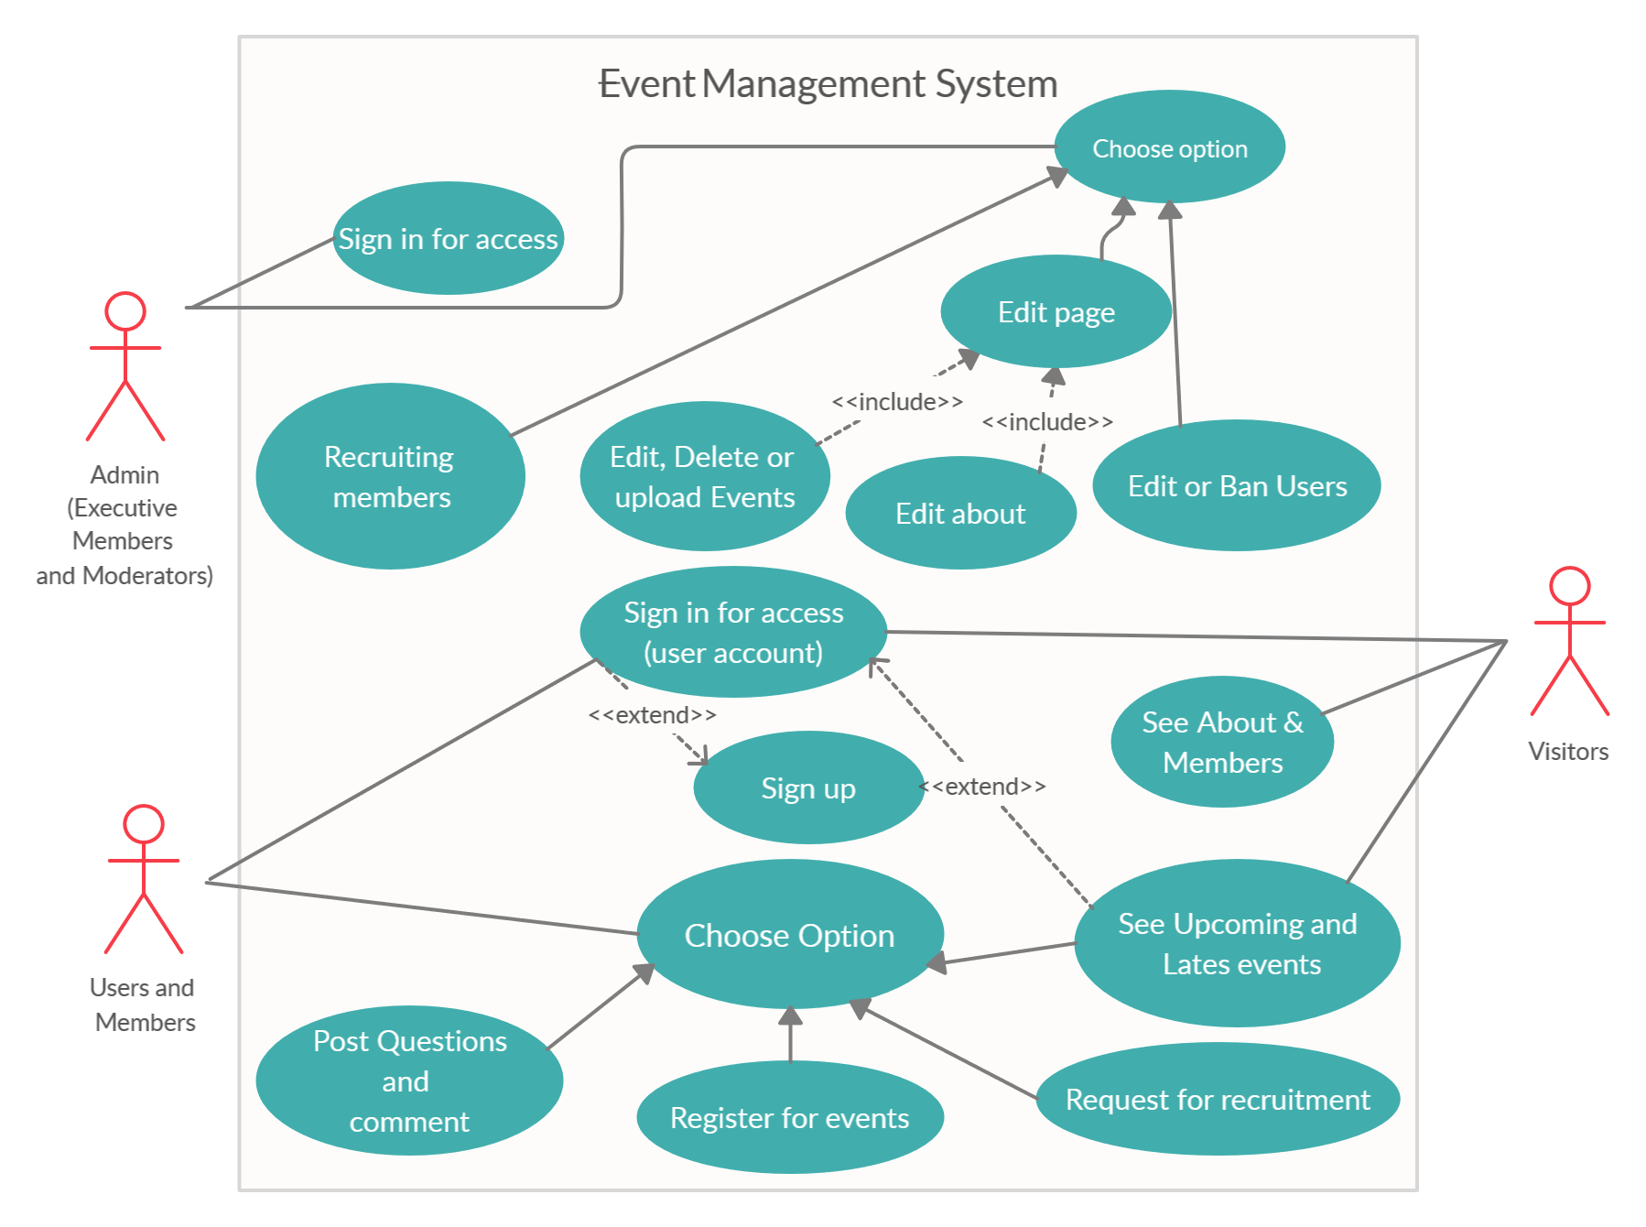

Use Case Diagram

**Class Diagram**

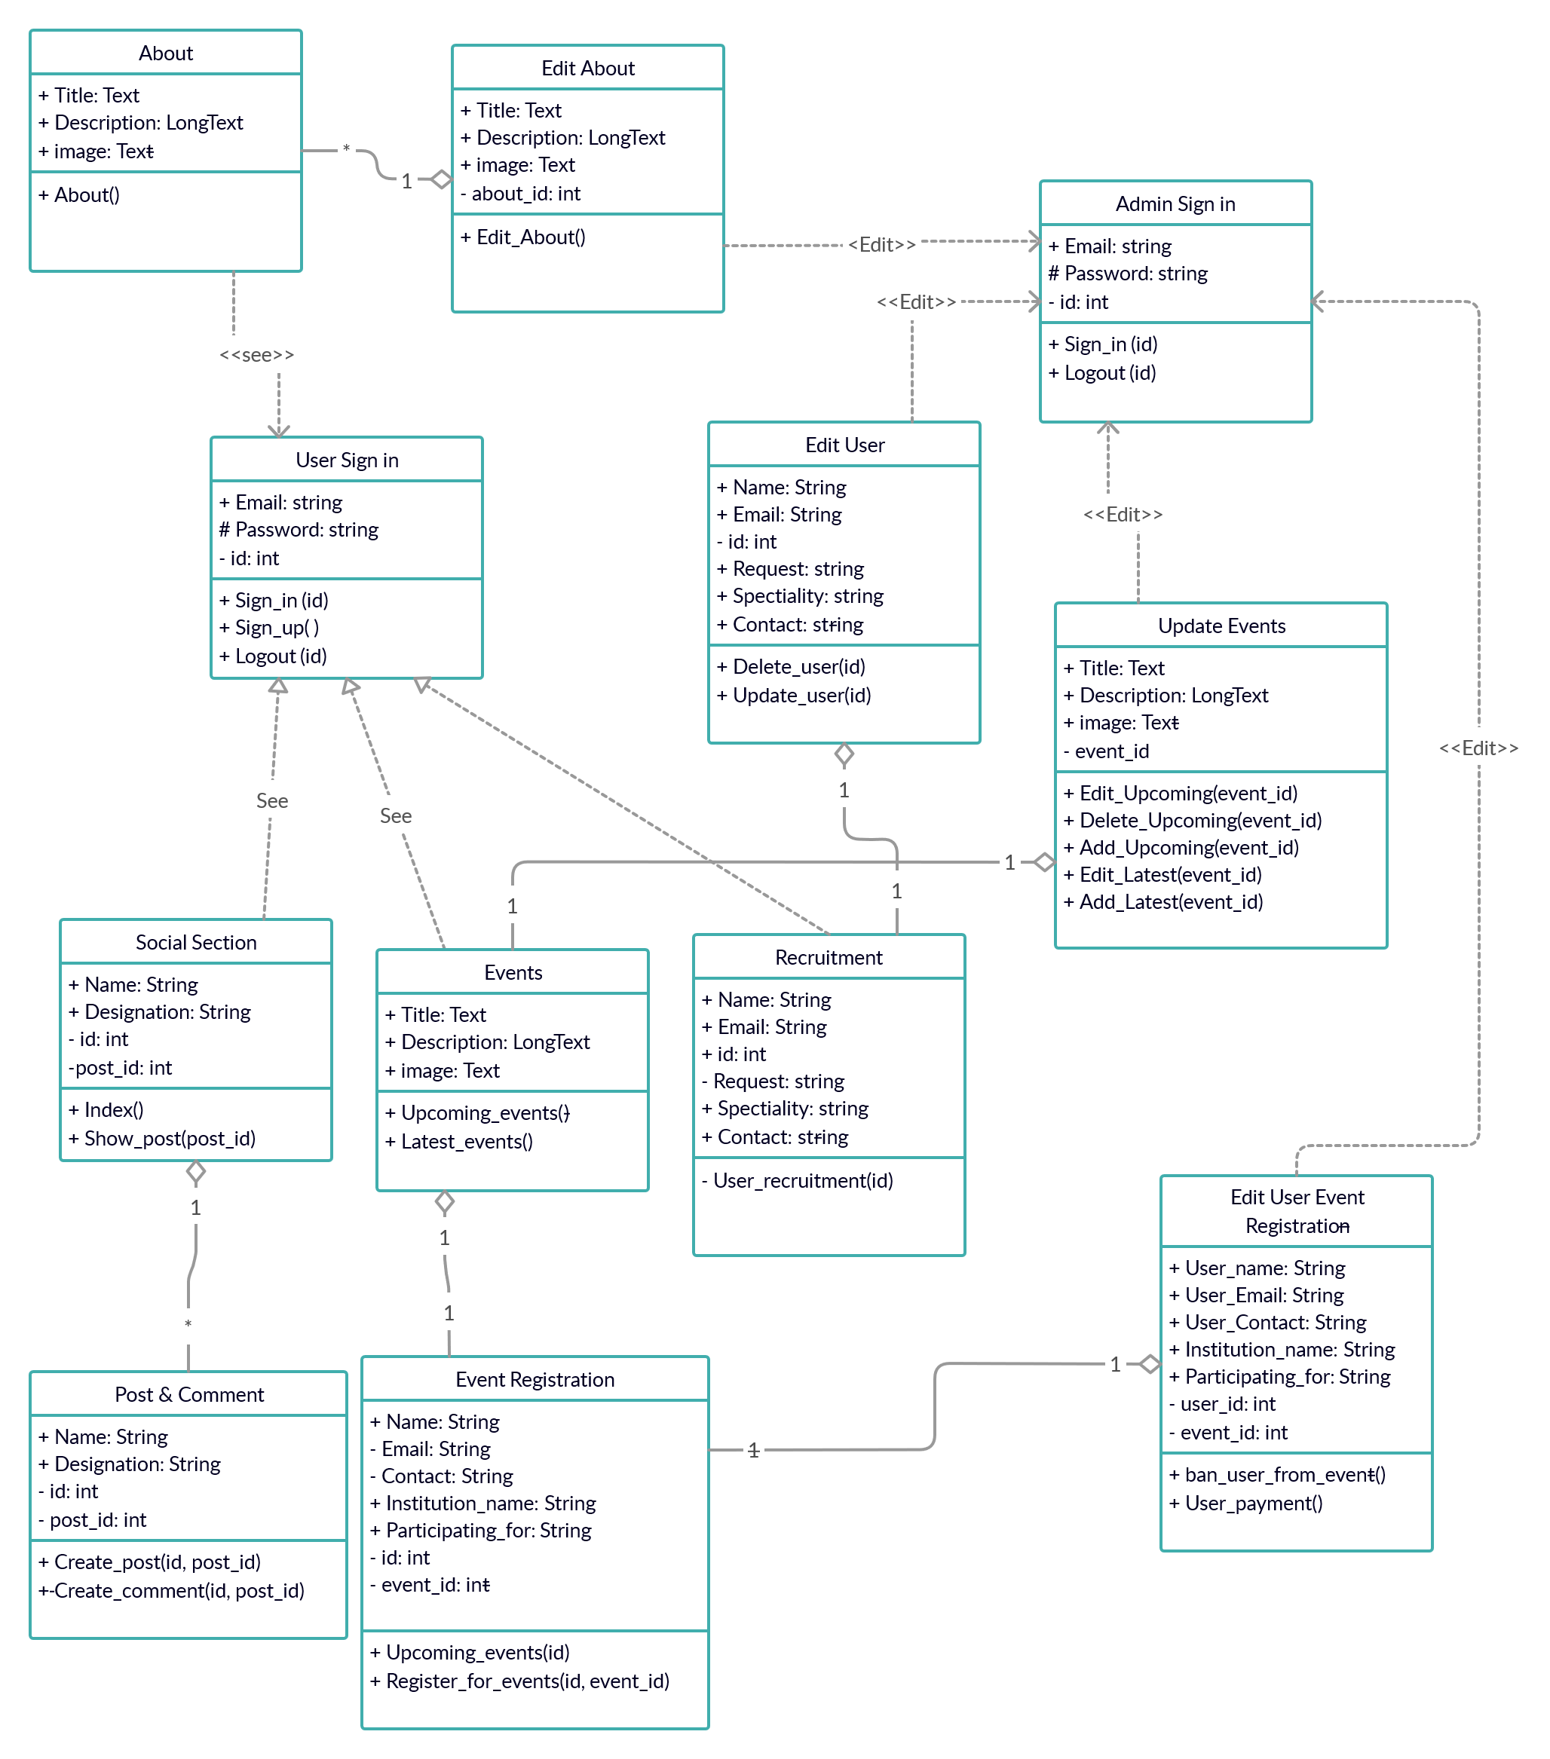

Class Diagram

**Activity Diagram (For User)**

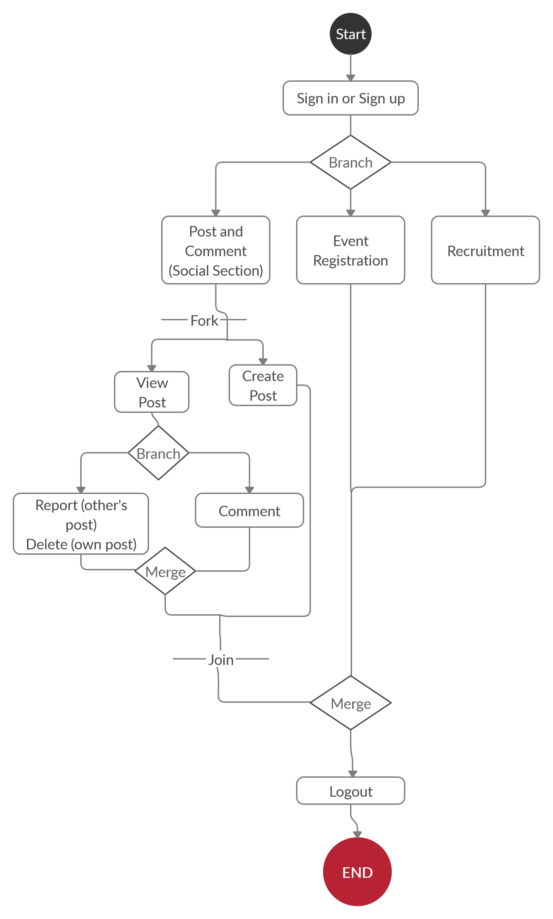

Activity Diagram (For User)

**Activity Diagram (For Admin)**

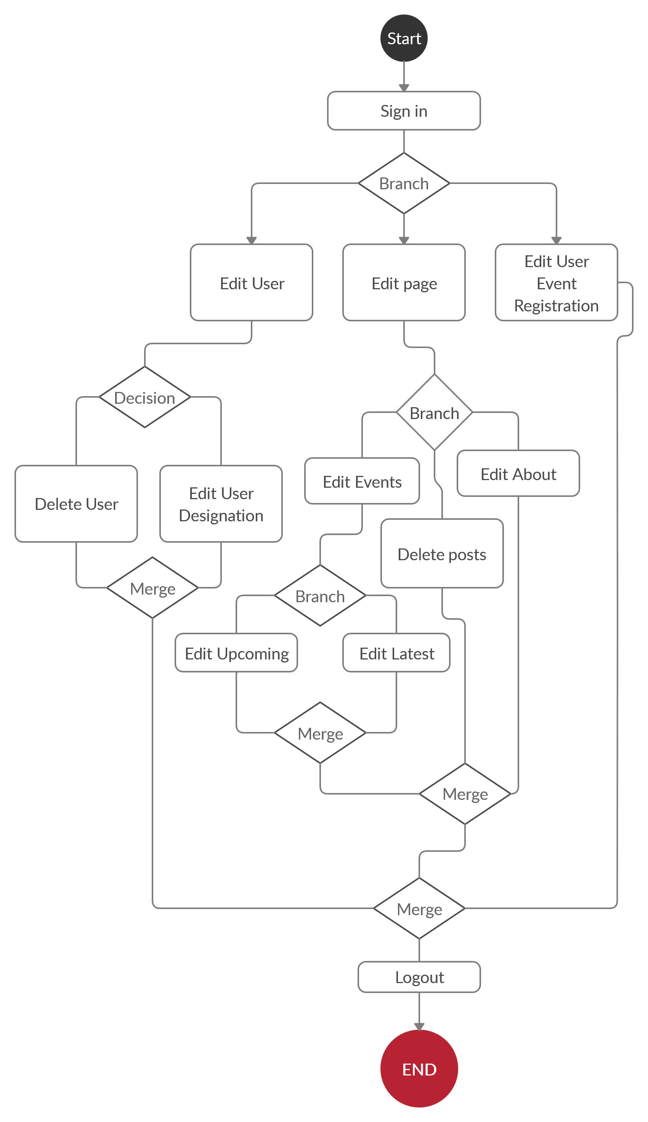

Activity Diagram (For Admin)

**Entity Relationship Diagram**

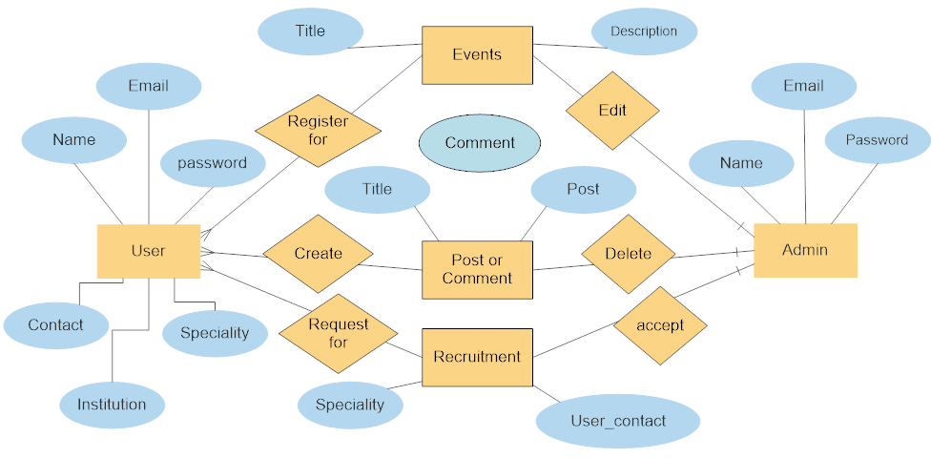

Entity Relationship Diagram

**Sequence Diagram**

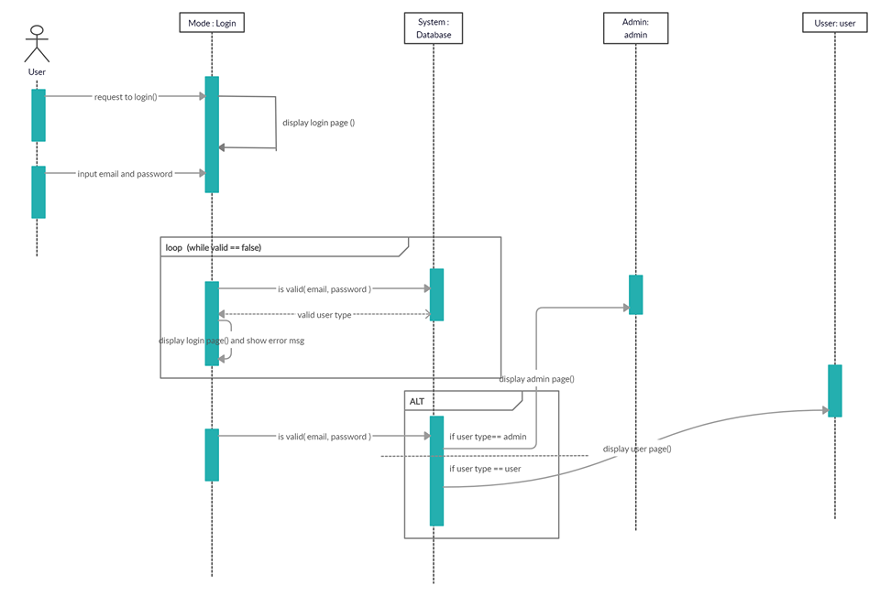

Sequence Diagram

**Limitations**

Nothing in this world is perfect. Everything in this world has its own limitations. We have faced problems developing the web application.

* In any edit data page, we have used buttons instead of drop down feature. Such as promoting users. We have met errors, trying to introduce drop down feature there. So we made decision to leave buttons for now.
* There is no registration for administrators. They have to contact with developers for registration as an admin.
* Posts cannot be edited but they can be deleted or reported. Comments cannot be deleted.

**Conclusion**

Developing this web-application has paved the way to think more and more about endless problems that arise while organizing an event. Mandatory things have been introduced in the web-application. But in future, with user’s satisfaction and request we are always keen to bring new functions and features in the application to ease many other sides of an event. This project has taught us so many important things about developing a web application. It was just a little step forward to take part in more complex, bigger and more challenging works that lies ahead in our future.

**Screenshots**

**Welcome Page**

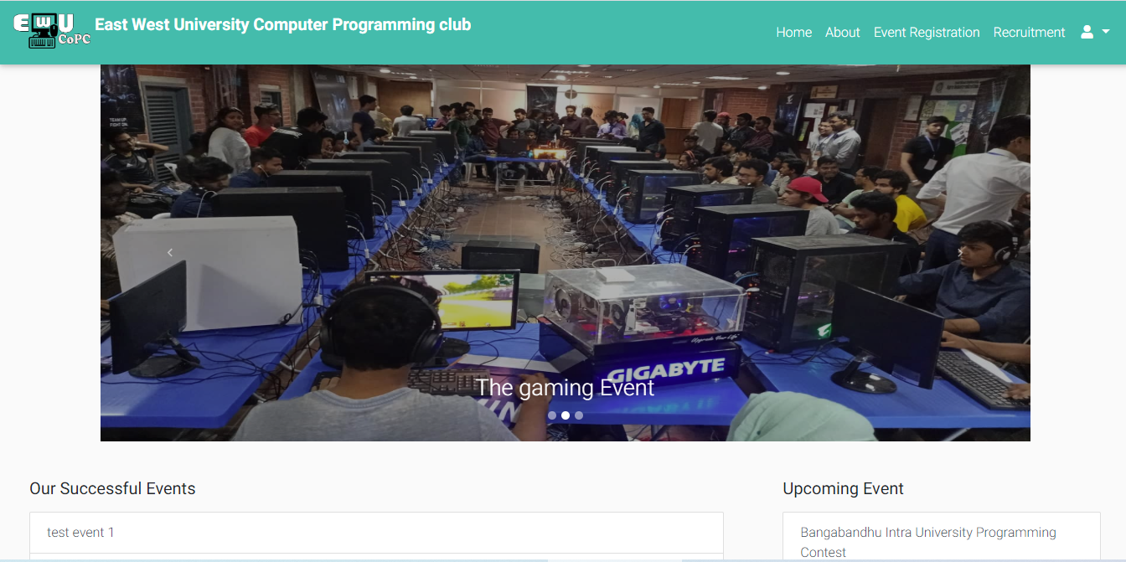

**About Page**

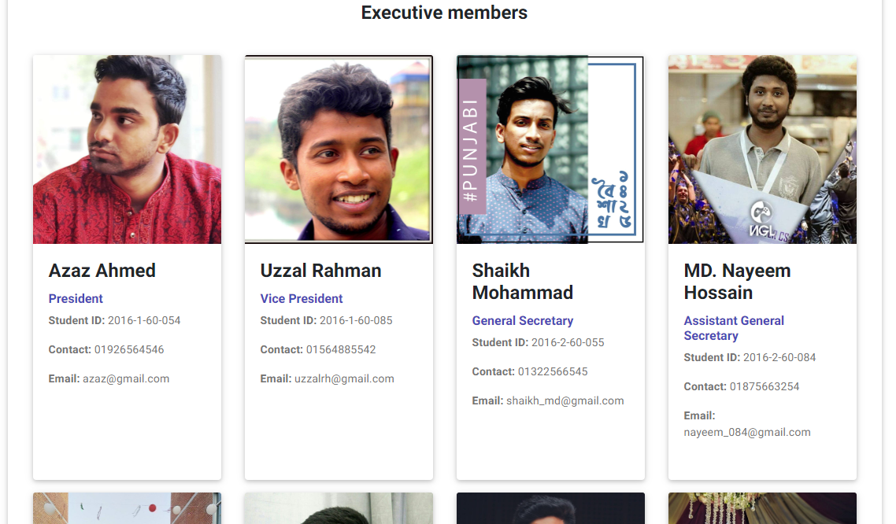

**User Login**

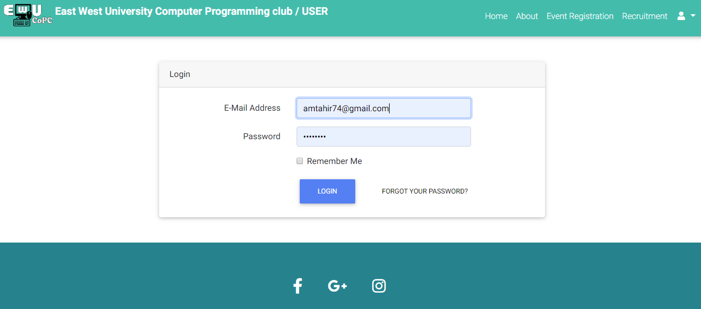

**User Home Page**

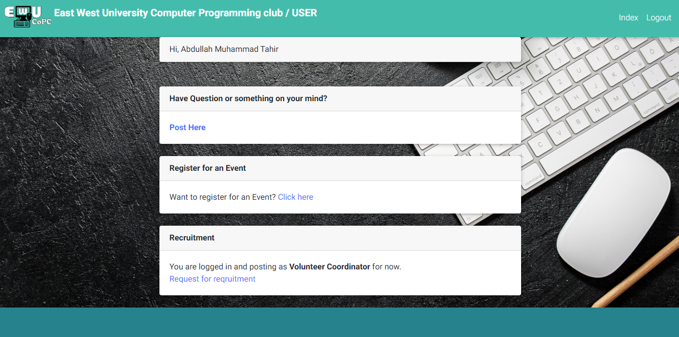

**Social Section (Creating Post)**

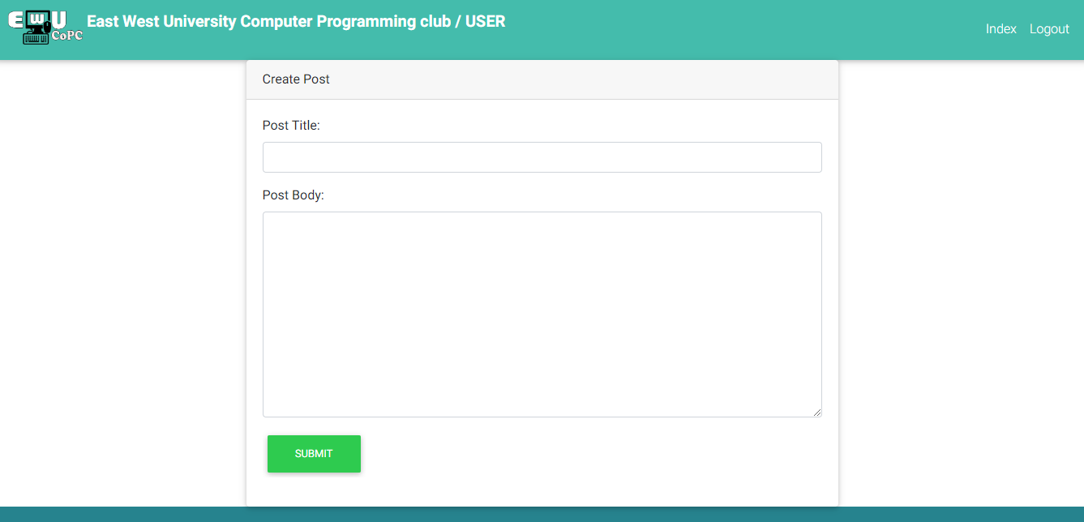

**Social Section (Viewing Posts)**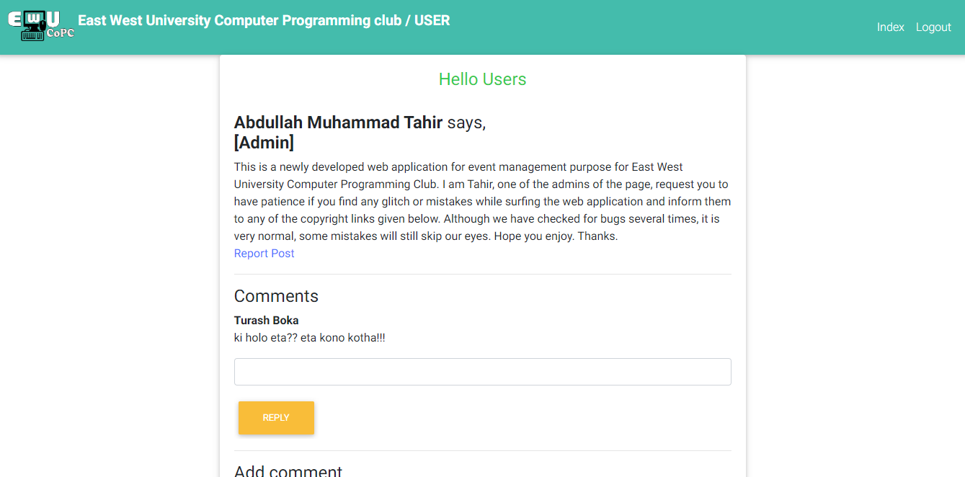

**Event Registration Page (View Registered and Ongoing events)**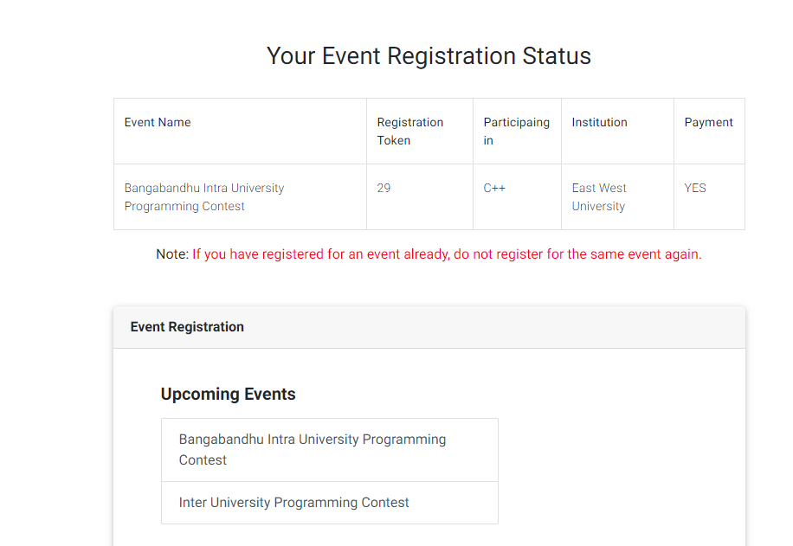

**Event Registration Page (Data Form)**

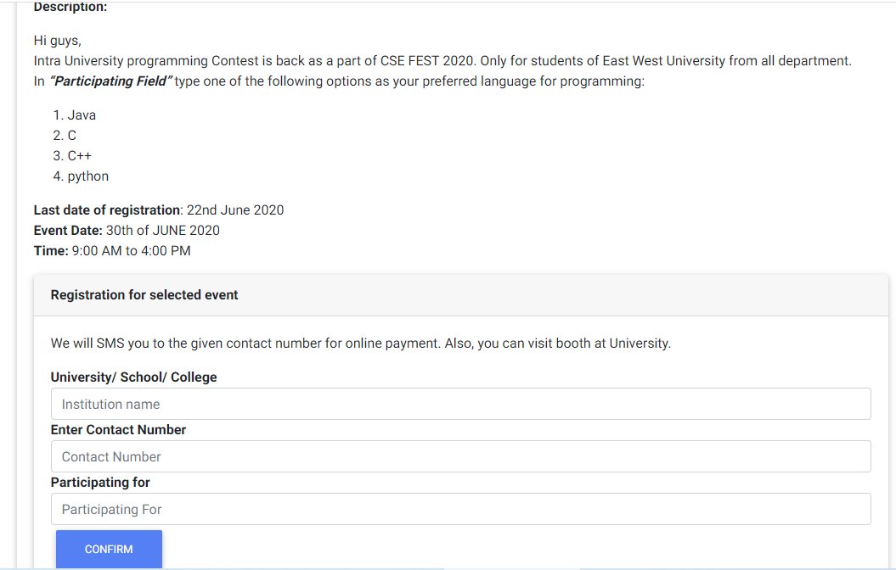

**User Recruitment**

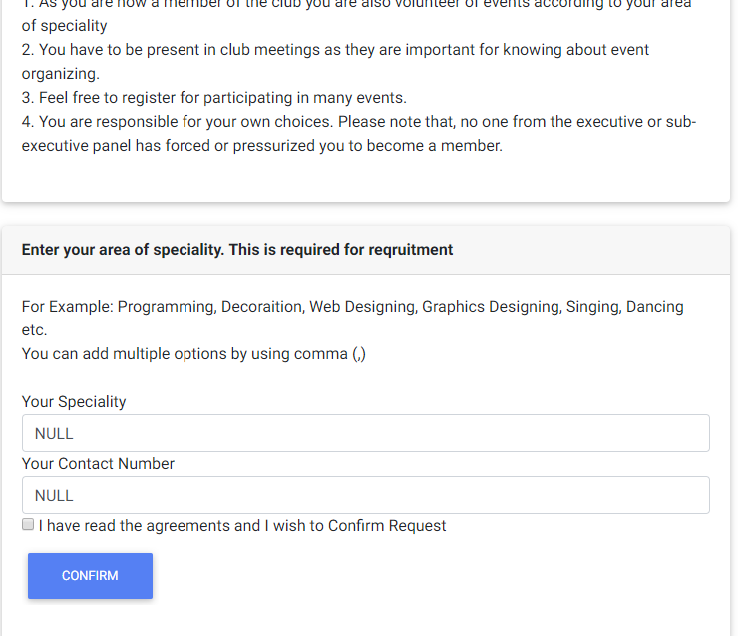

**Admin Home**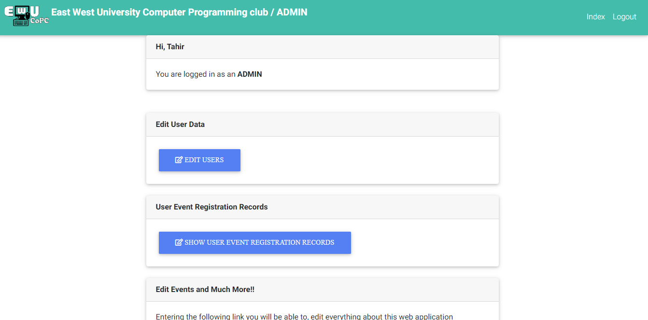

**User Editor Page (Recruitment & Banning)**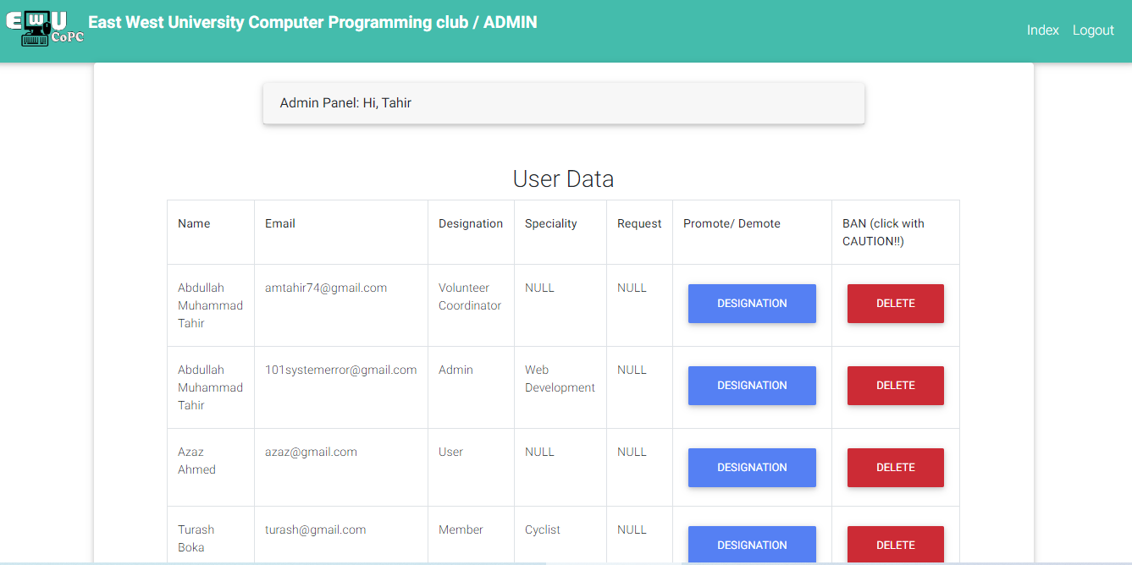

**Slider Editing Page**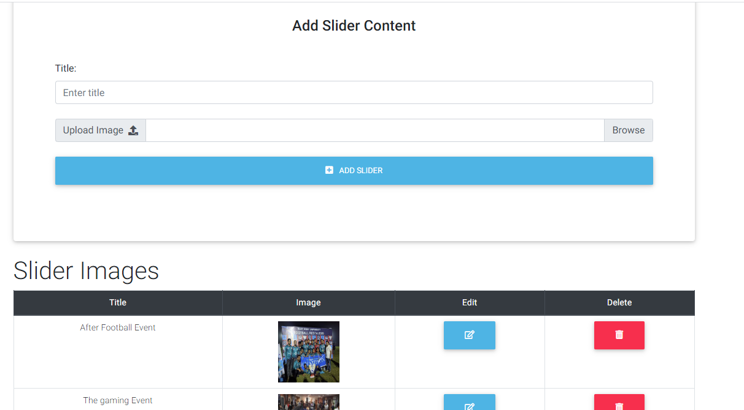

**Adding Next Event**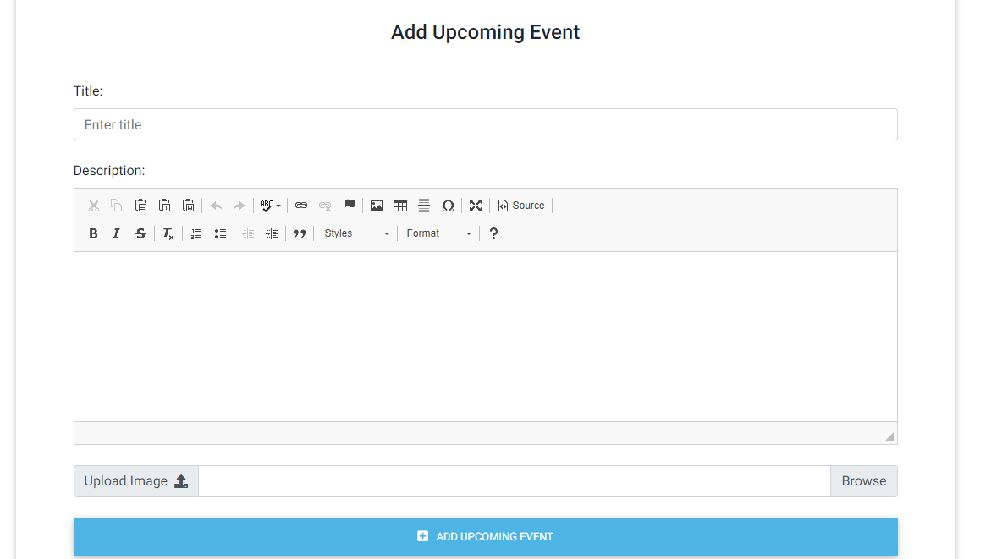

**About Editor**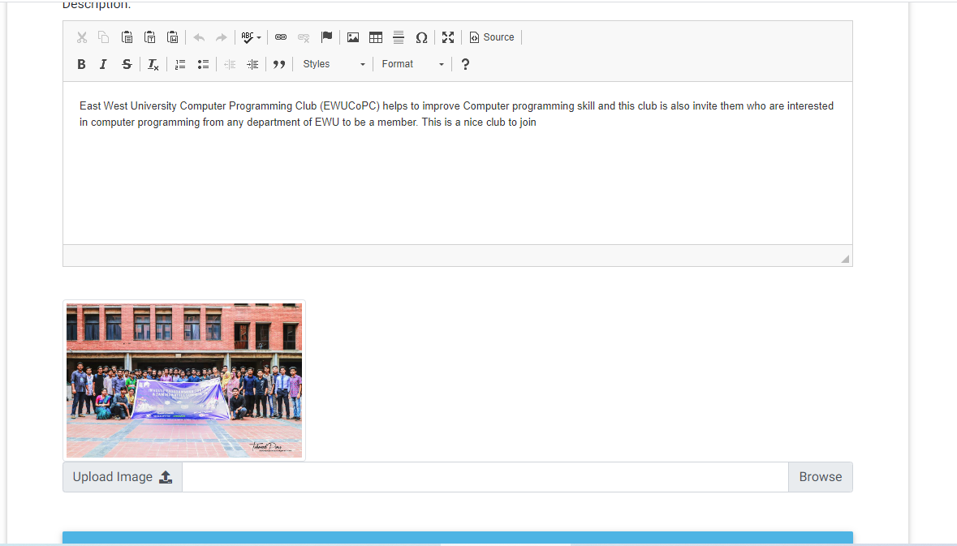

**User Registration Management**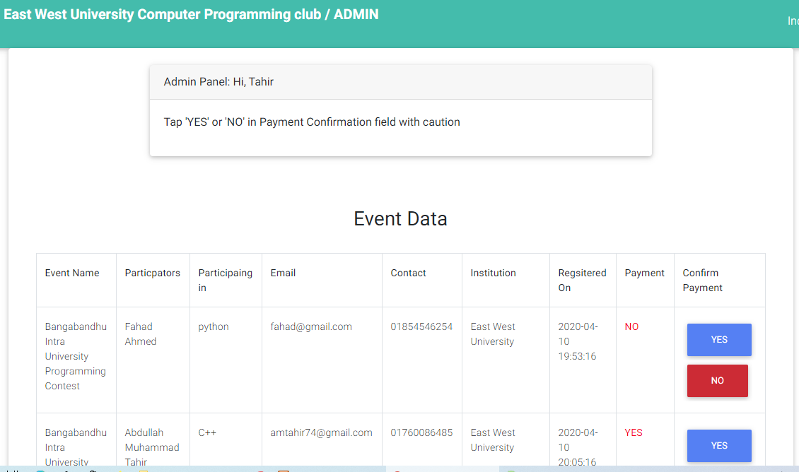

**Social Section Management (Deleting Reported Posts by user)**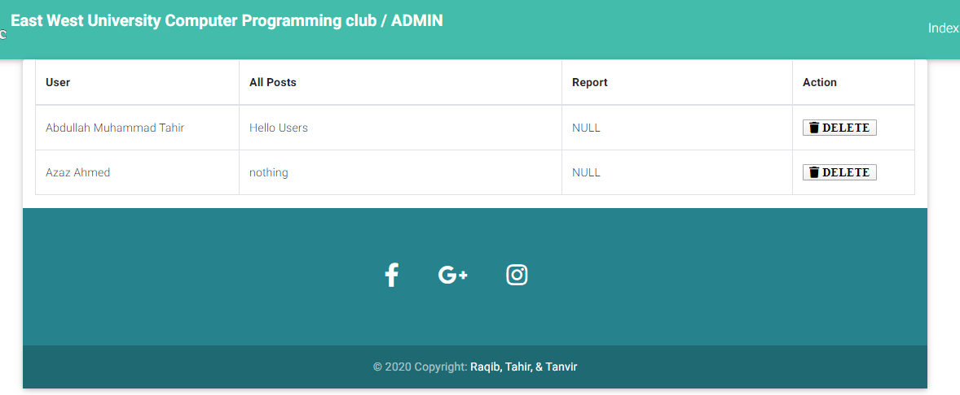

**List of Club members (From Welcome Page)**

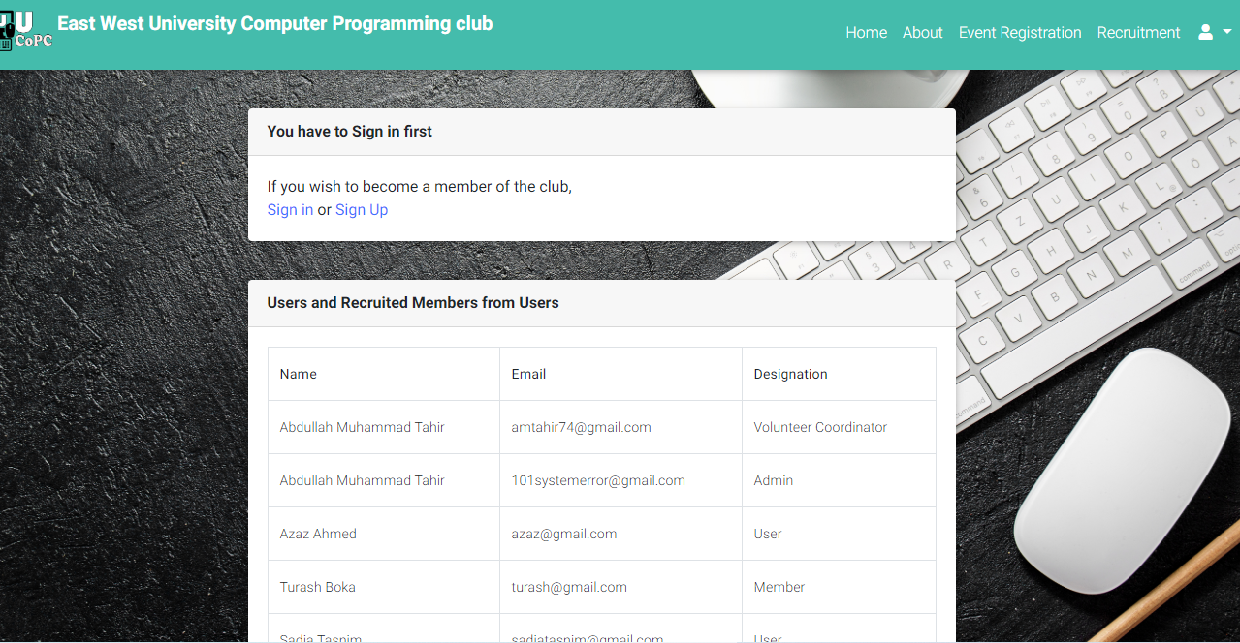

**--------------------------------------THE END------------------------------------**